Name :Sk.Kashifa

Register no :192121135

1. commerce registration system :

Class diagram :

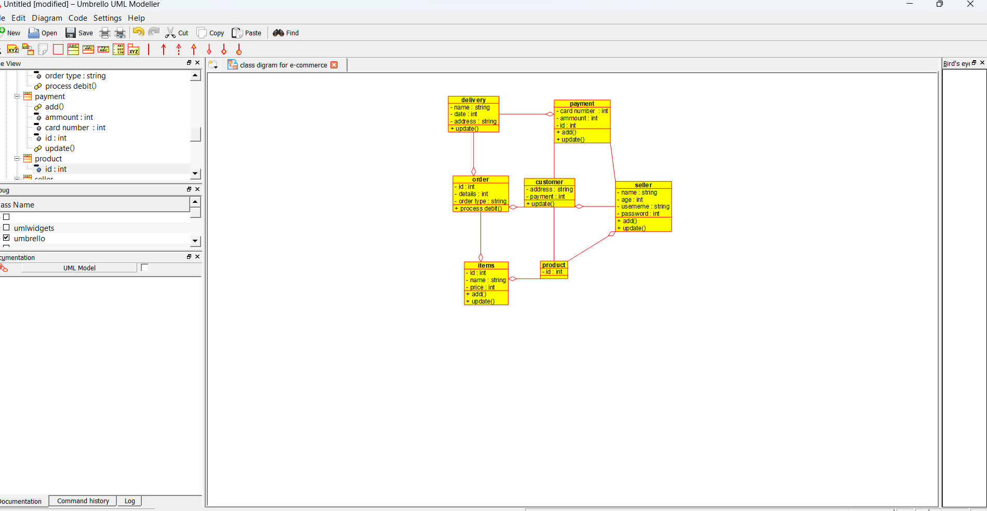

Package diagram :

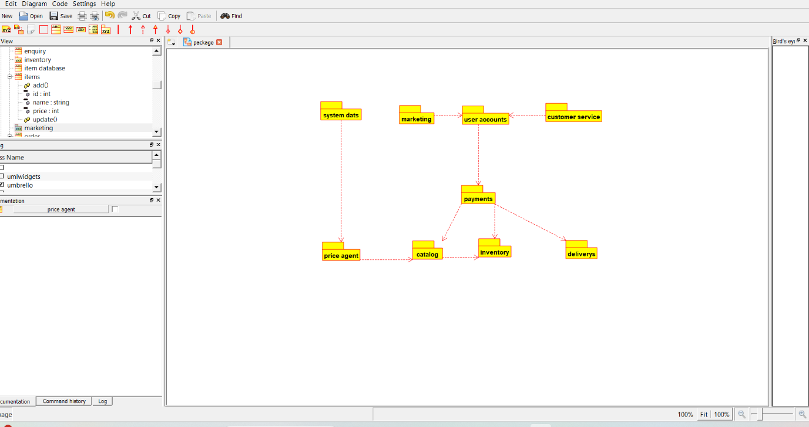

Deployment diagram :

